Question 1 part 1

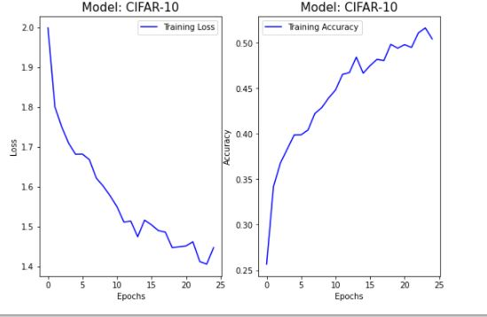

Figure 2 LeNet CNN with learning rate of 0.1 and accuracy = 0.54

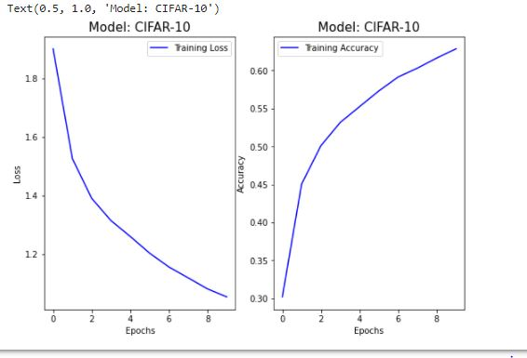

Figure 1 LeNet CNN with learning rate of 0.01 and accuracy = 0.64